
Getting started with Express Scripts Pharmacy by Evernorth® is easy. Managing your medications is even easier.

Once you’re registered and logged in to your account, it’s time to place your first prescription order.

Transfer prescriptions to home delivery
You’ll see any prescriptions eligible for delivery with Express Scripts Pharmacy, and how much money you could save by switching. Watch how



Start automatic refills
Get medications delivered right to your door when you need them. That’s one less thing you’ll have to remember. Watch how



Set up payment options
You can choose to set up automatic payments (up to an amount you designate) and a payment plan in minutes. Watch how

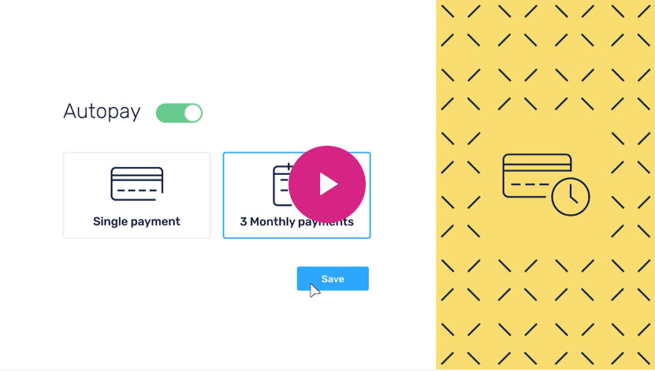

Ready to get started? Log in now

Express Scripts manages your prescription plan for <your employer, plan sponsor or health plan>/<Client Name>

© 2024 Evernorth Health Services. All Rights Reserved. All Rights Reserved. CRP2402_5888B

